**Pizza Cluster (First Iteration) June 28th ,2017**

**Project Abstract:**

Pizza Cluster is a brand-new way of ordering pizza online. It completely removes the inconvenience of finding a nearby pizza shop and placing an order over the phone. The online web application, on which the project is based on, will allow the user to signup, and create his own account. The user can then select a pizza place of his own choice and customize a pizza as per his preferences. It will also allow the user to monitor the delivery process in real-time.

**Customer:**

The customer is the owner of the ‘Pizza Cluster’ franchise. The customer wants to increase the efficiency and overall transparency of his business by making it easier for the clients to place an order in a manner which is both simple and efficient.

**Competitive Analysis:**

Some of the other franchises already have an online framework to receive orders. However, the online ordering for Pizza Cluster would be more intuitive and user-friendly compared to other websites. It will have unique features, like, it will allow the user to earn and redeem points on their purchases. It will also allow the end user to keep track of their previous purchases and view the most trending pizza on the website. Also, the user would be able to track the delivery process in real time.

**User Stories:**

1. Tom as the regular customer previously had a bad experienced with Pizza Cluster. As there were occasions when he didn’t quiet receive the pizza which he ordered over the phone. To address this issue, we have implemented a new user account system. According to this system, user would now be able to create his/her own account on the website and every time he/she will place an order, the order will be displayed to the kitchen and delivery staff by his/her name along with an address. This will eliminate the confusion and simplify the overall process. To test the new user account system, a sample account was created with different test cases and parameters. The tests were to check whether the system allows the user to create a new account or not. Also, it tested what would happen if user try to create a fake account with incorrect phone or home address. This feature was implemented in the first iteration.
2. John as the manger also had troubles to maintain all the orders that were placed over the phone. Often, some of the details like pizza crust, toppings, etc. were not mentioned by the customer and at times the delivery address and contact information were also missing. To address this issue, the manager would now be able to log in into the website using admin’s credentials and he would be able to see all the orders in an organized way. The user won’t be able to submit an order until and unless all the necessary order details and contact information has been entered correctly. In this way, all the necessary information would be stored in an organized way and any sort of confusion would be eliminated. This feature was implemented in the first iteration.
3. Another valuable customer, James, who although had a great overall experience with Pizza Cluster franchise stated that he usually prefers a very specific pizza from Pizza Cluster but every time he places an order, he had to give all the details again. To avoid this inconvenience, a new feature is added on the website to keep the record of user’s previous orders. Every time user will login into the website, he/she would be able to see his previous orders and he/she could then select the same order if they want and checkout.

**Future Iterations:**

1. Reward-Points. For every purchase user will get points which he/she can redeem on the next purchase.
2. User would be able to see the feedback of other customers about a certain type of bread or topping and based on that he can select his options.
3. Different payment options (Debit/Credit).
4. Real-time tracking using Google maps.

**User Interface Requirements:**

**Home Screen Layout:**

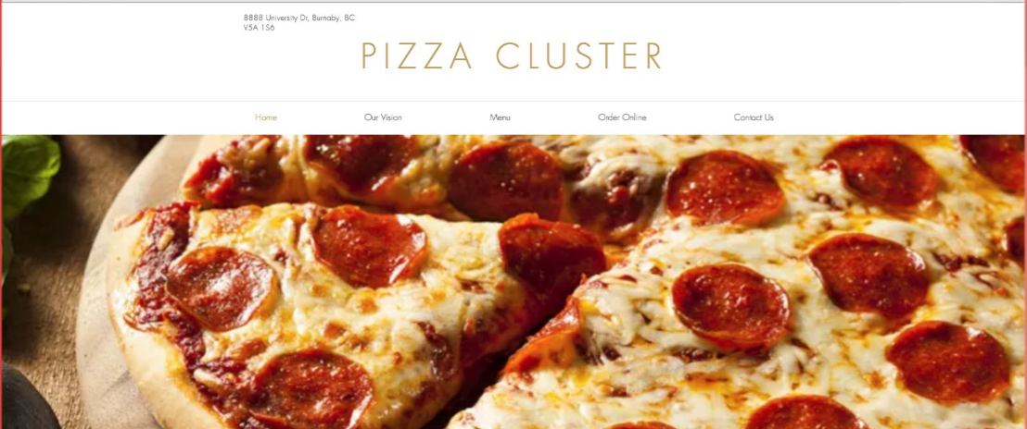

**Web pages:**

**Pizza Cluster**

Menu Online Order

**Menu**

Crust:

Flavour:

Toppings:

Salads:

**Sign In:**

Email: Passwords:

**Sign up:**

Name: Email: Password: Contact Number: Address:

**Checkout:**

**Address Confirmation:**

**Payment:**

**Order History:**

**Customize a new Pizza:**

Crust:

Flavour:

Toppings:

Salads:

**Backlog:**

|  |  |  |  |
| --- | --- | --- | --- |
| Login Credentials | Order History | Pizza Browsing | Creating Own Pizza |
| Payment Options | Real Time Tracking | Reward Point | Restaurant Review |
| Ordering Review |  |  |  |
|  |  |  |  |
|  |  |  |  |

**Group Members:**

* Arsalan Macknojia (301294147)
* Rishabh Thanki (301270143)
* Raghav Mittal (301307947)
* Ugur Akin (301269722)
* Liam Ling (301250516)